**Mongodb Lab 2 Exercise**

1. Perform the following DB operations using MongoDB.
   1. Create a collection by name Customers with the following attributes. Cust_id, Acc_Bal, Acc_Type
   2. Insert at least 5 values into the table

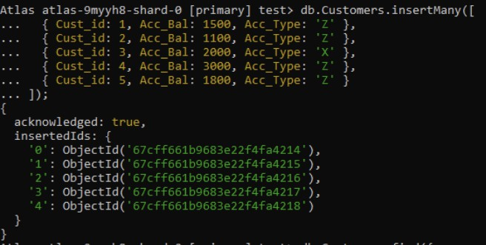

* 1. Write a query to display those records whose total account balance is greater than 1200 of account type ‘Z’ for each customer_id.

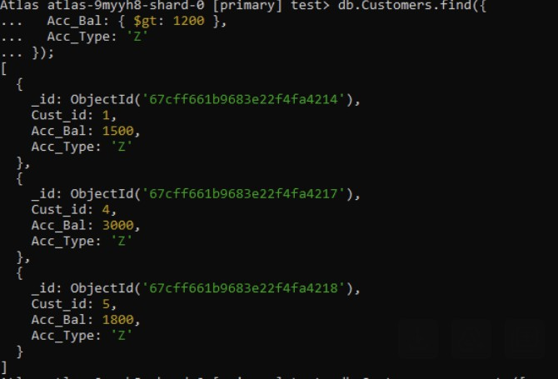

* 1. Determine Minimum and Maximum account balance for each customer_i

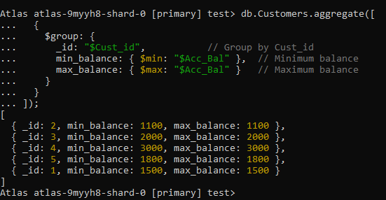

1. 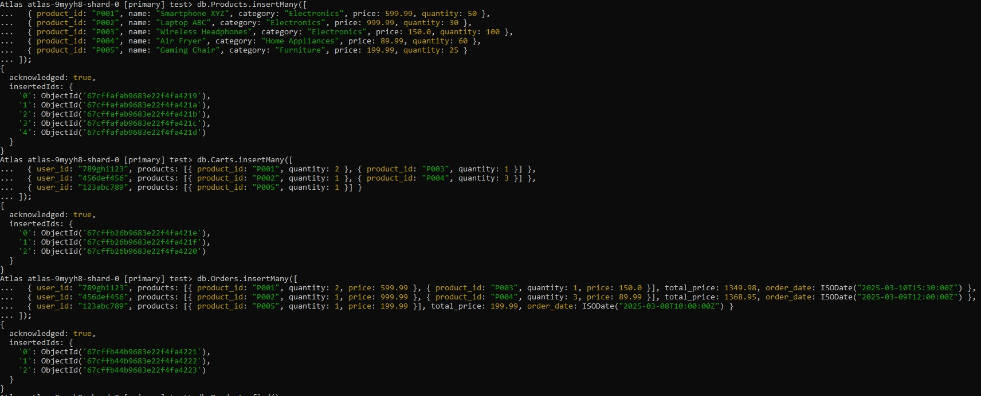You are developing an e-commerce platform where users can browse and purchase products. Each product has a unique identifier, a name, a category, a price, and available quantity. Additionally, users can add products to their cart and place orders. Design a MongoDB schema to efficiently handle product information, user carts, and orders.

Query to

Retrieve All Products.

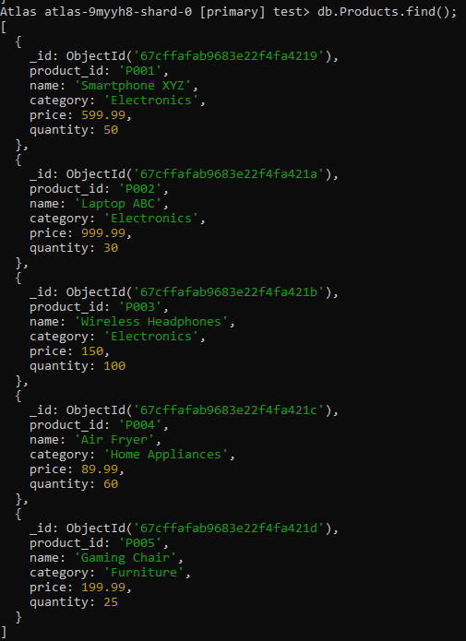

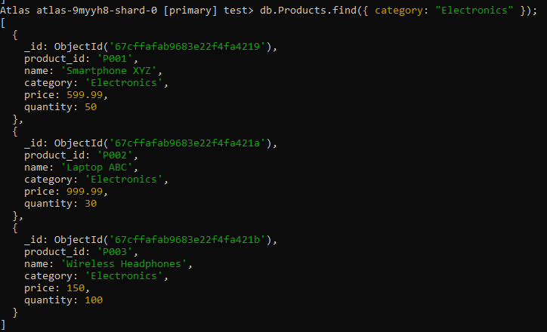Retrieve Products in a Specific Category (e.g., Electronics).

Retrieve Products with Quantity Greater Than 0.

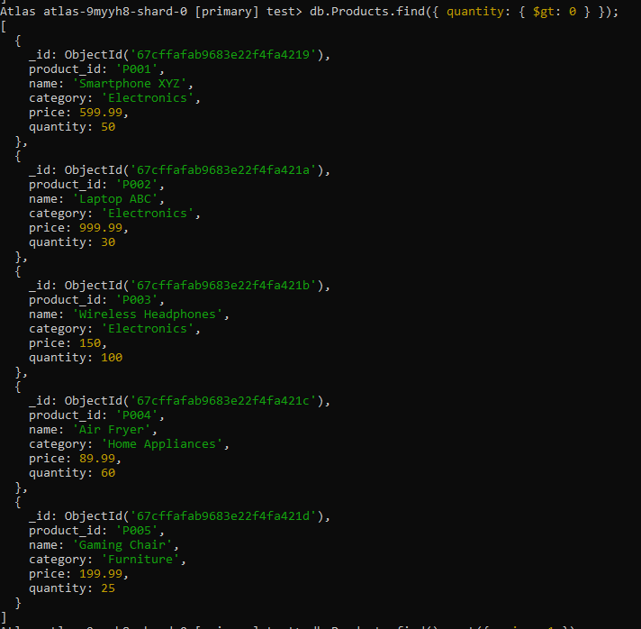

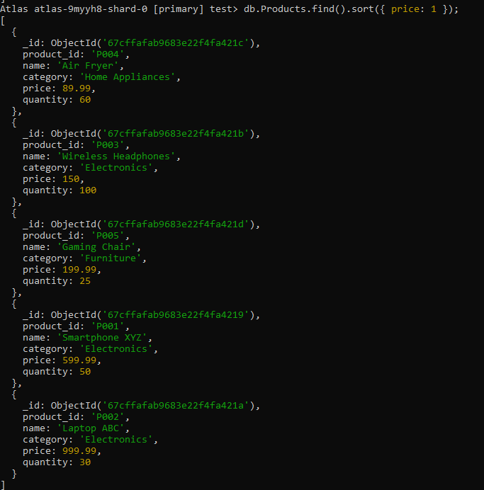Retrieve Products Sorted by Price in Ascending Order.

Retrieve Products with Price Less Than or Equal to $100.

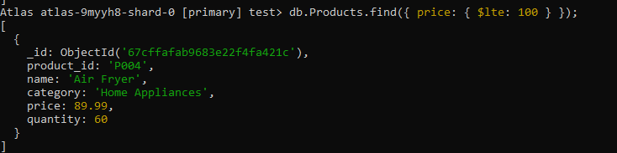

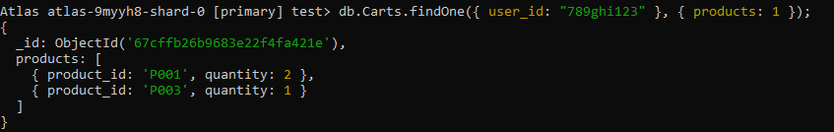Retrieve Products Added to a User's Cart (User with ID "789ghi...")

Retrieve Orders Placed by a User (User with ID "123abc...")

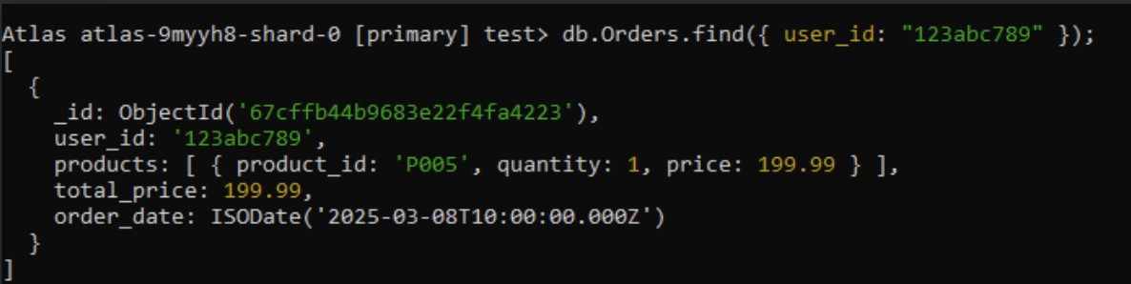

Retrieve Total Price of Orders Placed by a User (User with ID "123abc...")

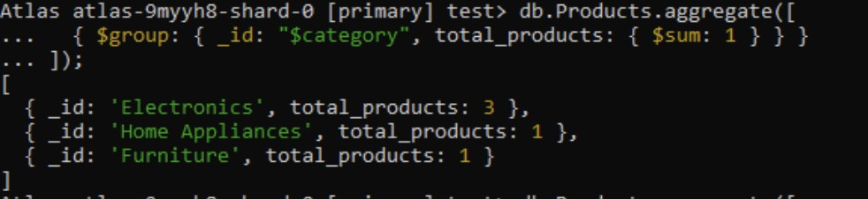Additional Aggregation queries based on Assignment-3 design: 1 .Calculate Total Number of Products in Each Category.

1. Calculate Total Price of Products in Each Category.

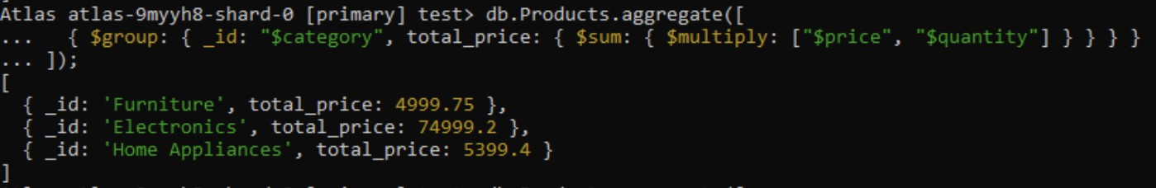

1. Find Average Price of Products.
2. Find Products with Quantity Less Than 10.



1. 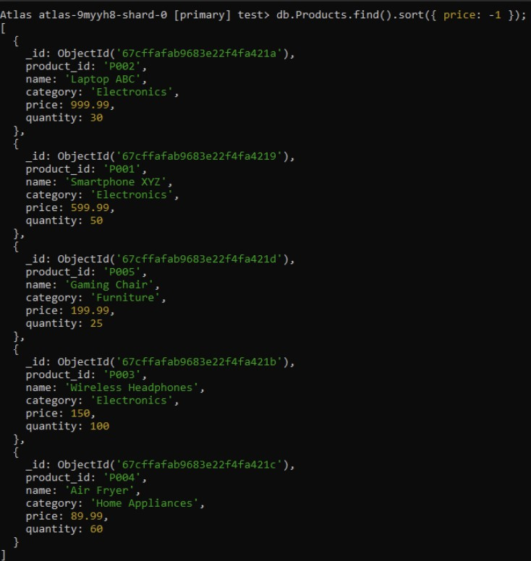Sort Products by Price in Descending Order.
2. 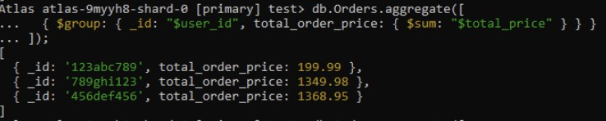Calculate Total Price of Orders Placed by Each User.
3. Find Users with the Highest Total Price of Orders.

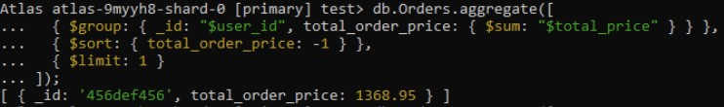

1. Find Average Total Price of Orders.